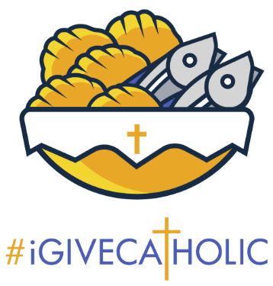
September 8th, 2025: Set your Goal
Welcome to #iGiveCatholic 2025! We are so excited and hope you will be joining us this year. If you haven’t registered, click Registration | #iGiveCatholic to do so. If you have registered, your next step is to come up with a goal and let everyone know about it!
This week, your task is to come up with a goal.
While every organization can always use more dollars, #iGiveCatholic on Giving Tuesday is a perfect opportunity to raise funds for a project that is:
- Specific: You can absolutely use #iGiveCatholic to raise funds for your general operating expenses, donors LOVE to give to a project that is specific. Think about your community: what is something that you NEED that your community could rally behind?
- Visible: Likewise, you want to choose a project that is VISIBLE, so that when donors see it, they can think “I supported that!”
- Achievable: It is important to choose a goal that you can realistically meet. Again, donors want to see their funds being put to good use. They can’t see a project if it hasn’t been completed due to lack of funds!
To help you craft your 2025 #iGiveCatholic Goal, check out this handy Goal Setting Guide!
To Do:
- Fill out the Goal Setting Guide.
- Set your goal:
  - What will you be raising funds for?
  - Is your goal monetary or is it to gain new donors?
  - What is the dollar amount you are raising?
- Collaborate with key partners to determine your goal.
If you have questions, contact the Annual Catholic Appeal Office, Jack Wagner at Jackwagner@archstl.com, or Brian Niebrugge at Niebruggeb@archstl.org.

