 | 
Health & Wellness Resource Update
September 2026


September National Health Observance
Immunization and Obesity Awareness
 |  | September’s health observances are Immunization and Obesity Awareness Month. Check out the following UnitedHealthcare educational resources to learn more about these topics:  - What’s a vaccine?  - Flu shots and flu locations  - What is body mass index? BMI  - 6 healthy habits for better living
United at Work Presentation of the Month
Mindful Eating
 |  |  |  | Mindful eating may be a helpful tool toward weight maintenance and food appreciation. During this presentation, we will begin by defining mindful eating. Additional topics include how to become aware of physical hunger and anxiety cues, and how to choose food that is pleasing and nourishing. Available to view in English and Spanish.
Health Tip Flier of the Month
Understanding Colds and Flu
 | 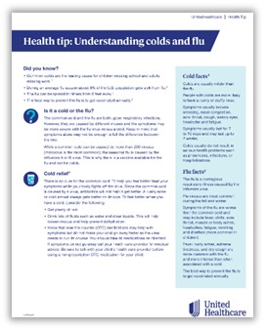 |  |  | Check out this month’s health tip flier Understanding Colds and Flu. Available in English and Spanish.
 | Health actions of the month
 |  |  | - Get your flu shot  - Practice mindful eating by keeping your phone away during meals
October preview

- Women’s Health and National Breast Cancer Awareness Month
- United at Work presentation: Women’s Health
- Health Tip Flier: Women’s Health

This email was sent by:
UnitedHealthcare
9700 Health Care Lane, Minnetonka, MN 55343
© 2025 United HealthCare Services, Inc.

Health plan coverage provided by or through UnitedHealthcare Insurance Company or its affiliates. Administrative services provided by United HealthCare Services, Inc. or their affiliates.

