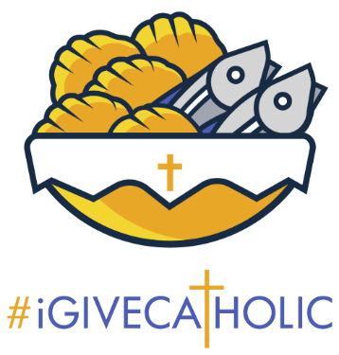
September 22, 2025: Setting up your Marketing

Welcome to #iGiveCatholic 2025! If you haven’t registered, click Registration | #iGiveCatholic to do so. We have videos, logos, email templates, and much more to help you maximize GivingTuesday donations.
If you have registered, It’s time for another weekly task suggestion. The purpose of our weekly task suggestions is to keep participating organizations moving forward at an acceptable pace, so everything is ready when Advance-Giving and Giving Tuesday come. In the past weeks, we suggested that organizations set their goals, and build their profiles. This week we suggest that you set up your marketing!
The word marketing can be intimidating, but no need to fret! Think of it simply as your plan for how you are going to let people know about your campaign. Let's start with a few guiding questions:
- Who is your target audience? Is it parishioners in your church, parents of students in your school, or supporters of your non-profit or ministry? Start with who is already in touch with your organization and work outward.
- What existing methods of communication do you use? Every organization has means in which they already communicate with their people. You just have to think about what those are and include your messaging about your campaign!
- How can you use these methods to communicate your campaign? Once you know which methods of communication you are going to utilize, you can begin to build out the content for your 2025 campaign!
To Do:
- Check out the Marketing Toolkit for ideas to utilize for your campaign!
- Do you use FLOCKNOTE? Look for the #iGiveCatholic library of email templates!
- Create a dedicated section for #iGiveCatholic messaging about your goal and/or project in all of your organization's email communications from October to December.
- Create and send a series of emails throughout the campaign (CLICK HERE for templates):
- “Save the Date” with description of the giving day, dates & your project/goal, any match opportunities or other campaign incentives.
- Create your own social media graphics with Canva, a free, easy-to-use online image making program. Then take advantage of all the #iGiveCatholic Canva templates!
- Use a social media scheduling program such as Later, Hootsuite or Buffer, allowing you to create and schedule posts days or months in advance.
- Use Bitly or TinyURL to create an “abbreviation” for your profile page URL.
Best Practices:
Christ the King Catholic Church (Mt. Pleasant, SC) used Flocknote to send this email explaining their goals to raise funds for Youth Ministry as well as to resurface their parking lot. The email includes:
- Their project goal
- Ways to help (including non-monetary ways to support the campaign!)
- Invitation to support the ministry in any way the donor is able
If you have questions, contact the Annual Catholic Appeal Office, Jack Wagner at Jackwagner@archstl.com, or Brian Niebrugge at Niebruggeb@archstl.org.

