 | 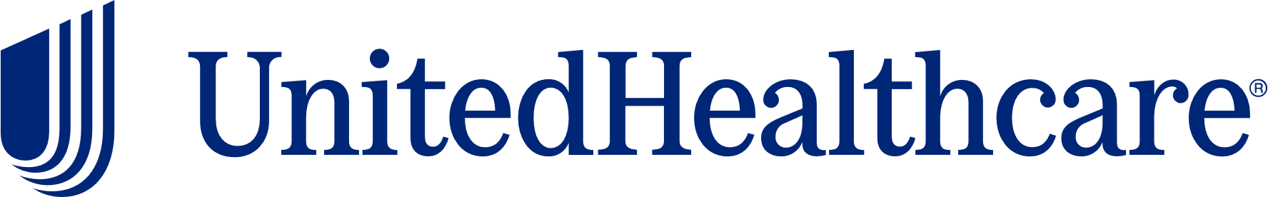
Health & Wellness Resource Update
August 2026


August National Health Observance
Sleep Health and Health Literacy Awareness Month
 |  | August’s health observances are Sleep Health and Health Literacy Awareness Month. Check out the following UnitedHealthcare educational resources to learn more about these topics:  - Types of health insurance costs  - Differences between HSAs, HRAs, and FSAs  - Sleep for health  - How to improve sleep and lead a healthier life
United at Work Presentation of the Month
Sleep for Health
 |  |  |  | Sleep is an all-encompassing part of your overall well-being, as it directly effects several factors related to your health status. This presentation will review the benefits of adequate sleep and risks due to insufficient sleep. You will also learn  how better sleep may improve your health, as well as tips to optimize sleep. Available to view in English and Spanish.
Health Tip Flier of the Month
Sleep for Health
 | 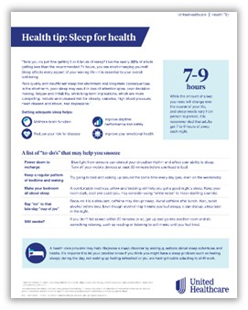 |  |  | Check out this month’s health tip flier Sleep for Health. Available to view in English and Spanish.
 | Health actions of the month
 |  |  | - Get 7 – 9 hours of sleep a night  - Unplug from screens 30 minutes before bed
September preview

- Immunization and Obesity Awareness Month
- United at Work presentation: Mindful Eating
- Health Tip Flier: Understanding Colds and Flu

This email was sent by:
UnitedHealthcare
9700 Health Care Lane, Minnetonka, MN 55343
© 2026 United HealthCare Services, Inc.

Health plan coverage provided by or through UnitedHealthcare Insurance Company or its affiliates. Administrative services provided by United HealthCare Services, Inc. or their affiliates.

