 | 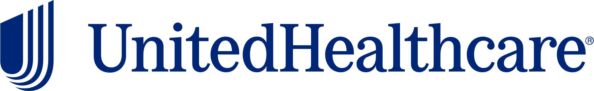
Health & Wellness Resource Update
March 2026


March National Health Observance
National Nutrition and National Colorectal Cancer Awareness
 |  | March’s health observances are National Nutrition and National Colorectal Cancer Awareness Month. Check out the following UnitedHealthcare educational resources to learn more about these topics:  - Nutrition tips for healthy eating  - Everyday nutrition  - Mindful eating  - Colon cancer symptoms and treatment
United at Work Presentation of the Month
Understanding Digestive Health
 |  |  |  | Digestion is a function your body must perform to live and thrive. However, there are many things that may lead to GI discomfort. This presentation will review the importance of “gut” health and the anatomy of the digestive system. It will also help participants understand how preventive care may help improve digestive health. Available to view in English and Spanish.
Health Tip Flier of the Month
Everyday Nutrition
 | 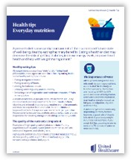 |  |  | Check out this month’s health tip flier Everyday Nutrition. Available to view in English and Spanish.
 | Health actions of the month
 |  |  | - Choose whole foods  (Such as fresh vegetables, fruits, whole grains, lean proteins, and heart-healthy fats)  - Schedule your colon cancer screening
April preview

- Alcohol & Substance Abuse and Stress Awareness Month
- United at Work presentation: Stress in the Workplace
- Health Tip Flier: Screen Time and Brain Health

This email was sent by:
UnitedHealthcare
9700 Health Care Lane, Minnetonka, MN 55343
© 2025 United HealthCare Services, Inc.

Health plan coverage provided by or through UnitedHealthcare Insurance Company or its affiliates. Administrative services provided by United HealthCare Services, Inc. or their affiliates.

