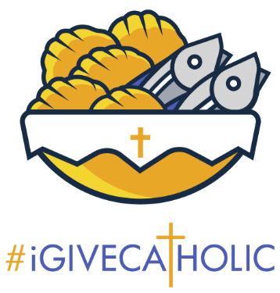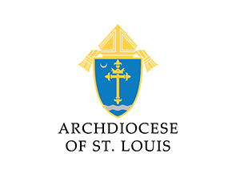
September 29, 2025: Matches
Welcome to #iGiveCatholic 2025! If you haven’t registered, click Registration | #iGiveCatholic to do so. We have videos, logos, email templates, and much more to make it easy to participate and to help you maximize GivingTuesday donations.
If you have registered, thank you! It’s time for another weekly suggestion. Our weekly suggestions are designed to keep participating organizations moving forward at a reasonable pace so everything is ready when Advance-Giving and Giving Tuesday begin. These past few weeks, we have suggested that organizations set their goals, build profiles, and set up marketing. Let me know if you did see the previous emails or if you want a copy of a previous email. This week we suggest that you focus on matches!
Why use matches? In 2024, organizations with matching funds raised on average 8x more than organizations without. 268 organizations featured a match or challenge last year, raising $2.5m!
Begin by soliciting your existing donors. Think of donors who have given in the past or give at the end of the year. Reach out to them and invite them to consider offering a match for your campaign. It’s no secret that matches are incredibly powerful in supercharging your campaign!
What opportunities could matches unlock for your organizations this year?
To Do:
- Check out this video or this article from Mightycause for directions on setting up a match!
- Click to see a CANVA TEMPLATE to create a custom Match flyer with a form for donors to complete.
- Review your donor database and begin reaching out to those who have given in the past. Ask them to partner with you for a match for this year’s campaign!
- Get creative: use challenges to further power up your match!
Best Practices:
Saint James Parish supercharged their 2024 campaign by stacking matches!
If you have questions, contact the Annual Catholic Appeal Office, Jack Wagner at Jackwagner@archstl.com, or Brian Niebrugge at Niebruggeb@archstl.org.

