 | 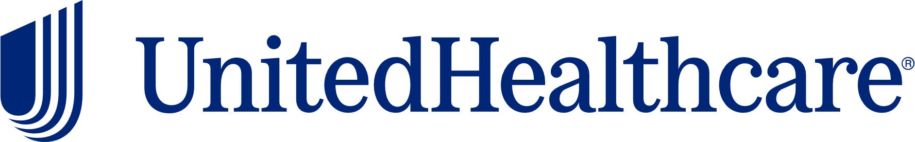
Health & Wellness Resource Update
April 2026


April National Health Observance
Alcohol & Substance Abuse and Stress Awareness
 |  | April’s health observances are Alcohol & Substance Abuse and Stress Awareness Month. Check out the following UnitedHealthcare educational resources to learn more about these topics:  - Substance use disorder (drug abuse)  - Substance use helpline  - Stress  - Anxiety and anxiety disorders
United at Work Presentation of the Month
Stress in the Workplace
 |  |  |  | Jobs of all types may bring stress to one’s life. During this presentation, we will define stress and the effects it may have on you and discuss ways you may effectively deal with stress in the workplace. Available to view in English and Spanish.
Health Tip Flier of the Month
Screen Time and Brain Health
 | 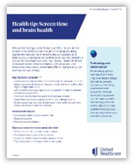 |  |  | Check out this month’s health tip flier Screen Time and Brain Health. Available to view in English and Spanish.
 | Health actions of the month
 |  |  | - Try an alcohol-free month to reset habits  - Take breaks from news and social media
May preview

- Mental Health Awareness and National Physical Fitness & Sports Month
- United at Work presentation: Everyday Mindfulness
- Health Tip Flier: Stand for Health

This email was sent by:
UnitedHealthcare
9700 Health Care Lane, Minnetonka, MN 55343
© 2026 United HealthCare Services, Inc.

Health plan coverage provided by or through UnitedHealthcare Insurance Company or its affiliates. Administrative services provided by United HealthCare Services, Inc. or their affiliates.

