 | 
Health & Wellness Resource Update
January 2026


January National Health Observance
Preventive Care, Cervical Health and Wintertime Safety
 |  | January’s health observances are Preventive Care, Cervical Health and Wintertime Safety. Check out the following UnitedHealthcare educational resources to learn more about these topics:  - Preventive care checklist: common tests & screenings for your age  - How to find a primary care doctor  - Understanding cervical cancer
United at Work Presentation of the Month
Cold Weather and Wintertime Safety
 | 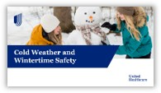 |  |  | When the temperatures drop, it's important to be ready. During this presentation, we will review cold weather-related health risks, including hypothermia and frostbite. We'll also discuss how to weatherproof your home, dressing appropriately in cold situations outdoors, and how to travel safely during winter storms. Available to view in English and Spanish.
Health Tip Flier of the Month
Cold Weather & Wintertime Safety
 | 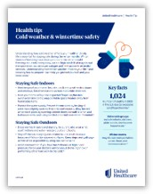 |  |  | Check out this month’s health tip flier on Cold Weather & Wintertime Safety. Available to view in English and Spanish.
 | Health actions of the month
 |  |  | - Schedule your annual wellness exam  - Schedule your cervical cancer screening
February preview

- National Heart Health and Eye/Vision Health Awareness
- United at Work presentation: Know Your Health Numbers
- Health Tip Flier: DASH Eating Plan

This email was sent by:
UnitedHealthcare
9700 Health Care Lane, Minnetonka, MN 55343
© 2025 United HealthCare Services, Inc.

Health plan coverage provided by or through UnitedHealthcare Insurance Company or its affiliates. Administrative services provided by United HealthCare Services, Inc. or their affiliates.

